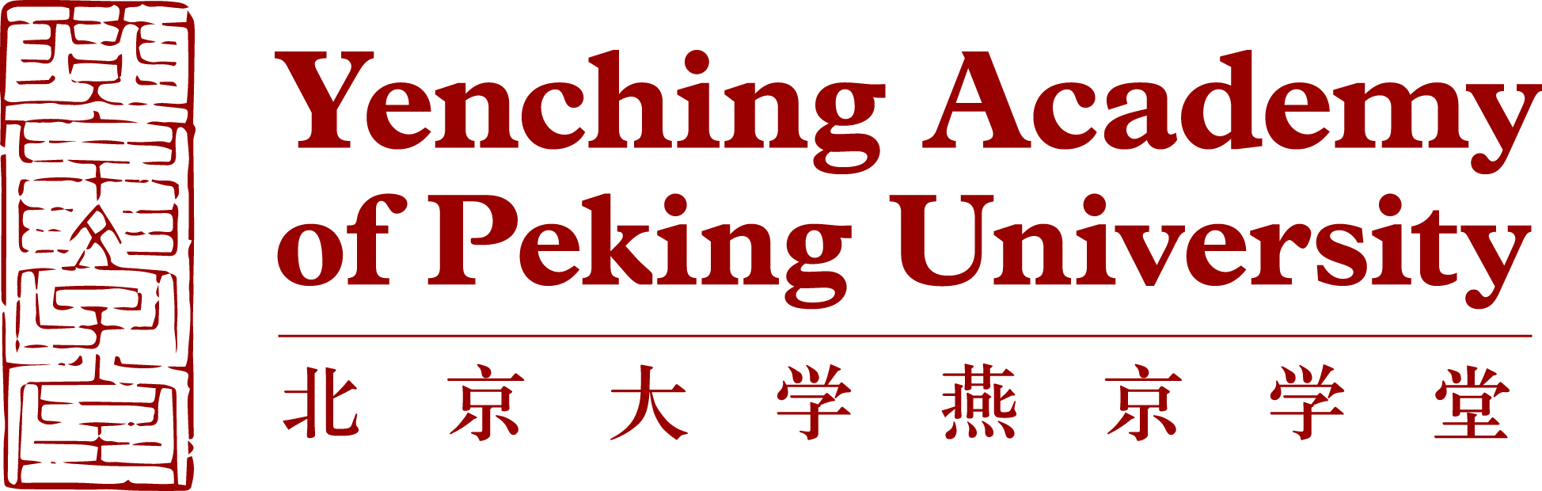

Biographical information
Background Information | Family Name (as shown on passport)
 | Given Name (as shown on passport)
 | Middle Name (as shown on passport)
 | Sex
 | Date of Birth (dd/mm/yyyy)
 | Country/Region of Birth
 | Country/Region(s) of Citizenship
Language | Native Language
 | Other Languages (please specify level of fluency) | Language 1
 |  | Language 2
 |  | Language 3
Correspondence Address | Current Postal Address (where you currently reside)
 | Address
 | City
 | State/Province
 | Zip/Postal Code
 | Country
 | Permanent Mailing Address (if different from current address)
 | Address
 | City
 | State/Province
 | Zip/Postal Code
 | Country
Other Contact Information | Email Address (preferred)
 | Secondary Email Address
 | Skype Username
 | Primary Phone Number
 | Secondary Phone Number

Academic Background
Academic  Background | University
 | Location (city, state, country)
 | School or Department
 | Major
 | Second Major (if any)
 | Minor (if any)
 | Month and Year of Graduation (or expected)
 | Degree
Current GPA (out of 4.0)
If your university uses a different grading system, please indicate the grading scale used and your standing within this scale.
Recommender 1  Peking University only accepts recommendation letters written by full professors or associate professors (or equivalent titles) | Name
 | Organization/Company
 | Job Title
 | Phone Number
 | Formal University/Company Email Address
 | Relationship with the Applicant
Recommender 2  Peking University only accepts recommendation letters written by full professors or associate professors (or equivalent titles) | Name
 | Organization/Company
 | Job Title
 | Phone Number
 | Formal University/Company Email Address
 | Relationship with the Applicant
Study Plan
Item | Details
Degree | Name of Degree | Master of China Studies
 | Preferred Research Area  (Research Areas affect thesis topic and advisor, but does not limit course selection options.) | Please Choose (√)one of six concentrations  ○Philosophy and Religion  ○History and Archaeology  ○Literature and Culture  ○Economics and Management  ○Law and Society  ○Politics and International Relations
 | Year of Entry | 2021
Language Requirement | IELTS (Academic)
 | TOEFL (iBT)
 | Cambridge English Scale (Advanced)
 | CEFR
 | • English Proficiency Test Score (for those whose first language is not English or are not graduating from a primarily English-taught degree program)
Chinese Language Level (not required) | HSK Test Level and Score(s)

Personal Statement and Research Proposal
The personal statement, not to exceed 750 words in English, should include a self-introduction and well-articulated explanation of how the candidate would make the most of the Yenching Academy program experience, as well as how it would benefit the candidate’s career. The research proposal (maximum one page) should include key research question(s), background to study and/or summary of literature, and study design.

Nominees’ online application packages should include the following documents, in English: Personal statement (750 words or less); research proposal (maximum one page); Curriculum Vitae; official transcript(s); diploma(s) and/or certificate of enrollment; English proficiency score report. Two letters of recommendation should be provided by the Partner University to Yenching Academy via email.

